

***INSTITUTE OF INFORMATION TECHNOLOGY***

***JAHANGIRNAGAR UNIVERSITY***

**Number of Lab Report :** 02

**Name of Lab Report :** JK flip flop(7473) truth table visualization.

**Course Tittle :** Digital Logic Design Lab

**Course Code :** ICT – 2104

**Submission Date :** 04/02/2021

**Submitted To Submitted By**

[Dr. Md. Sazzadur Rahman](https://juniv.edu/teachers/rhemel) MD. Shakil Hossain

Assistant Professor Roll – 2023

IIT – JU 2nd year 1st Semester

IIT – JU

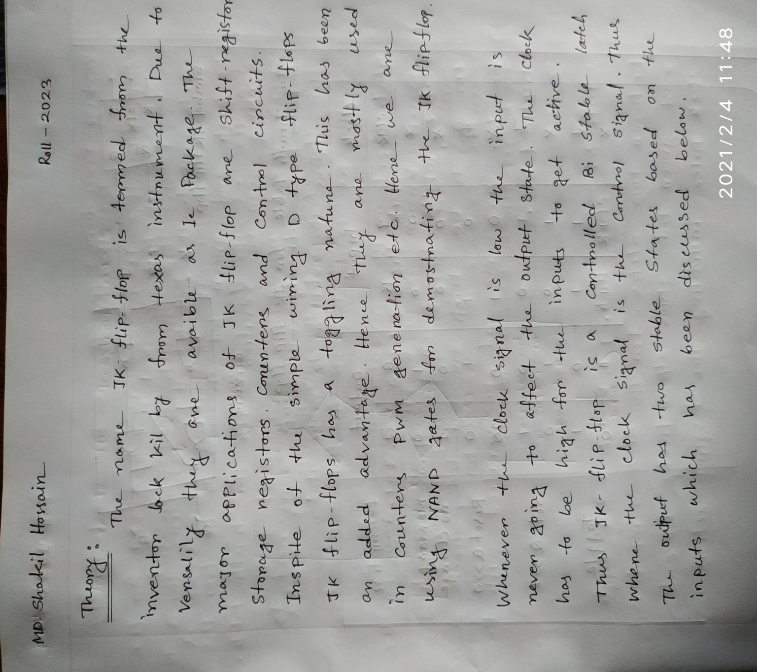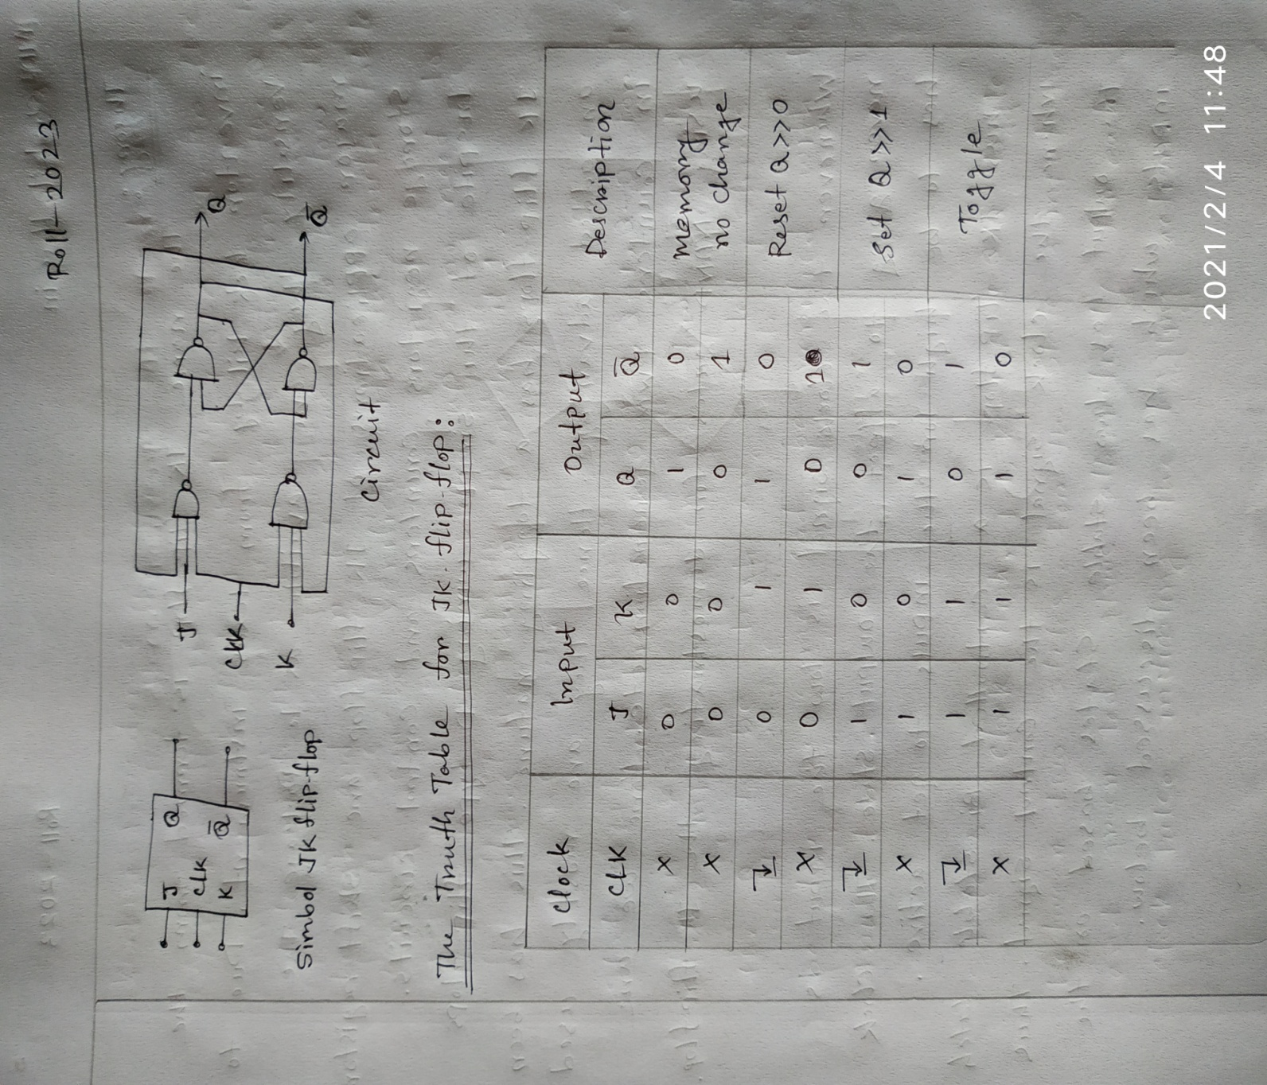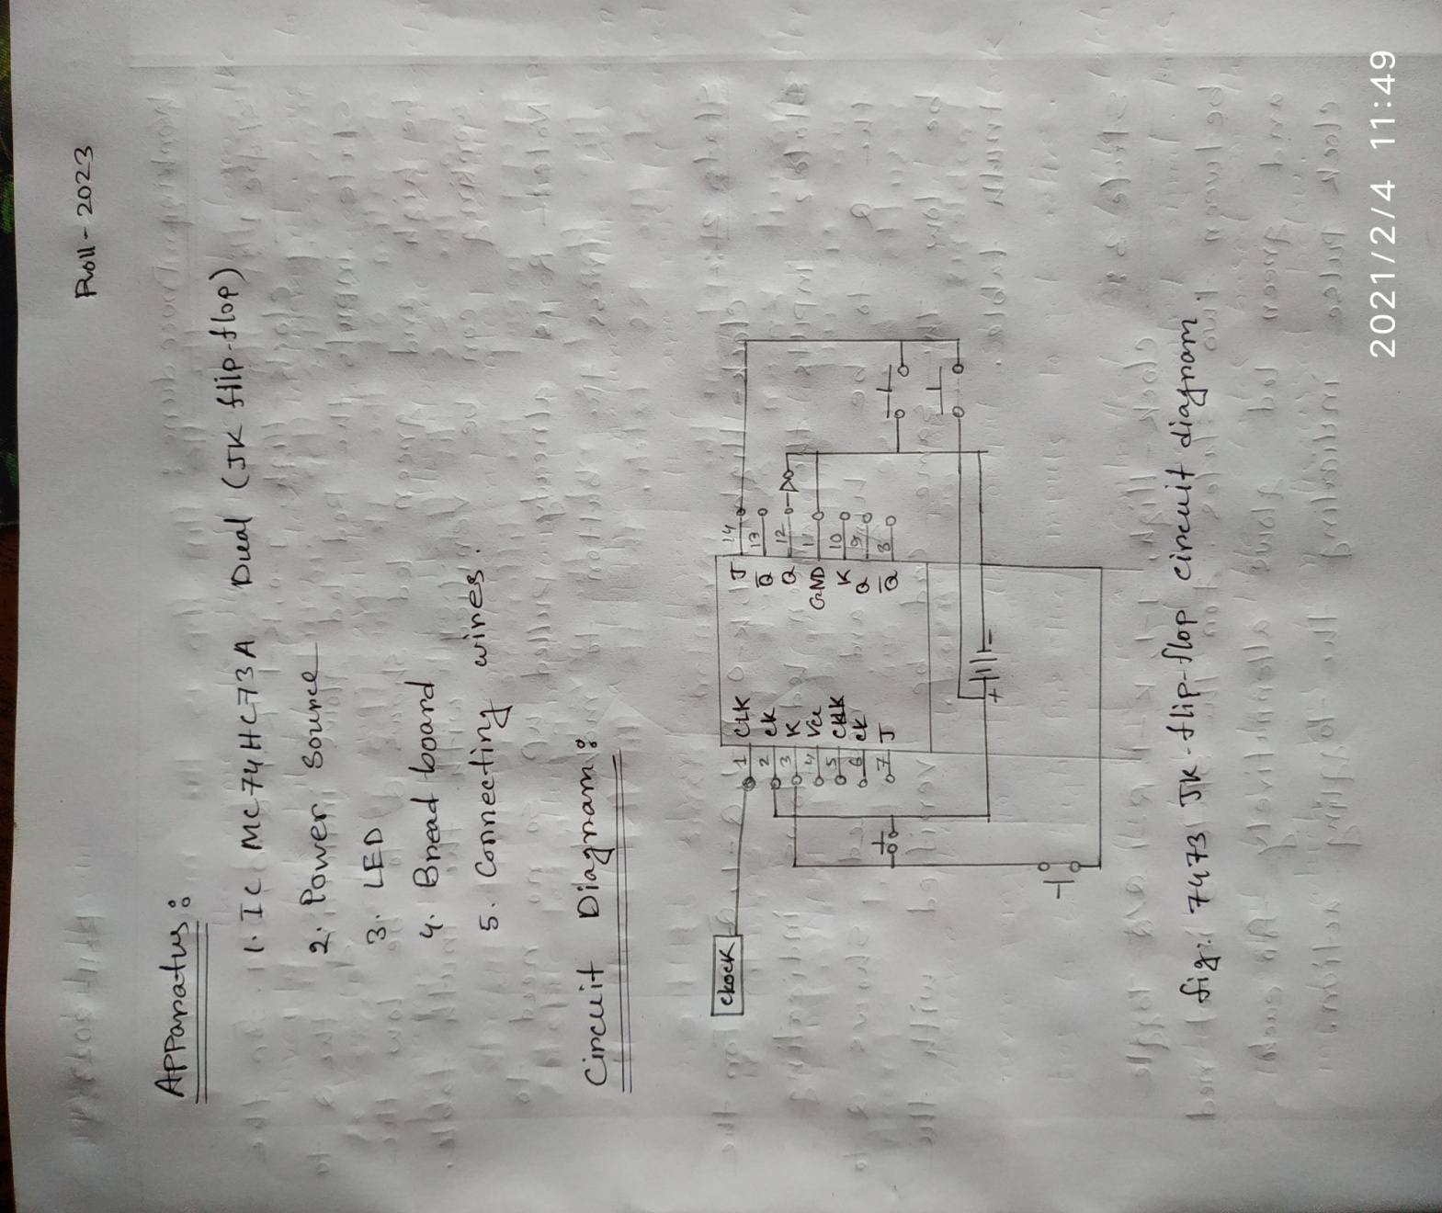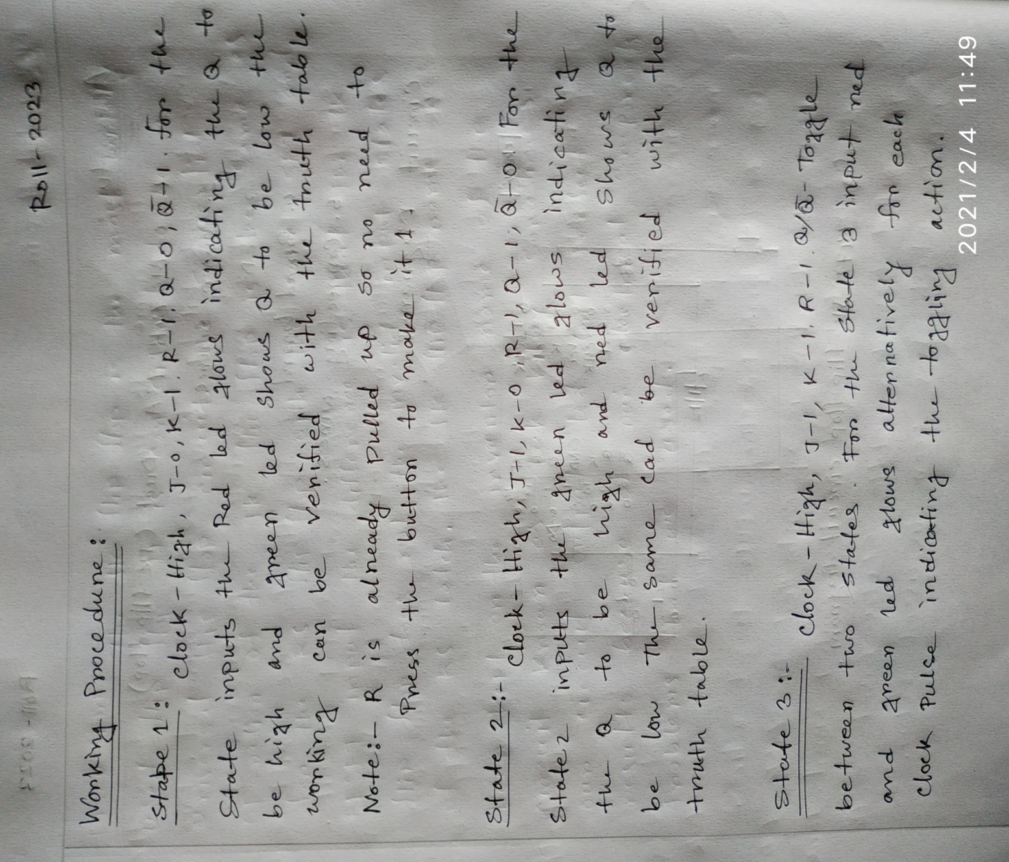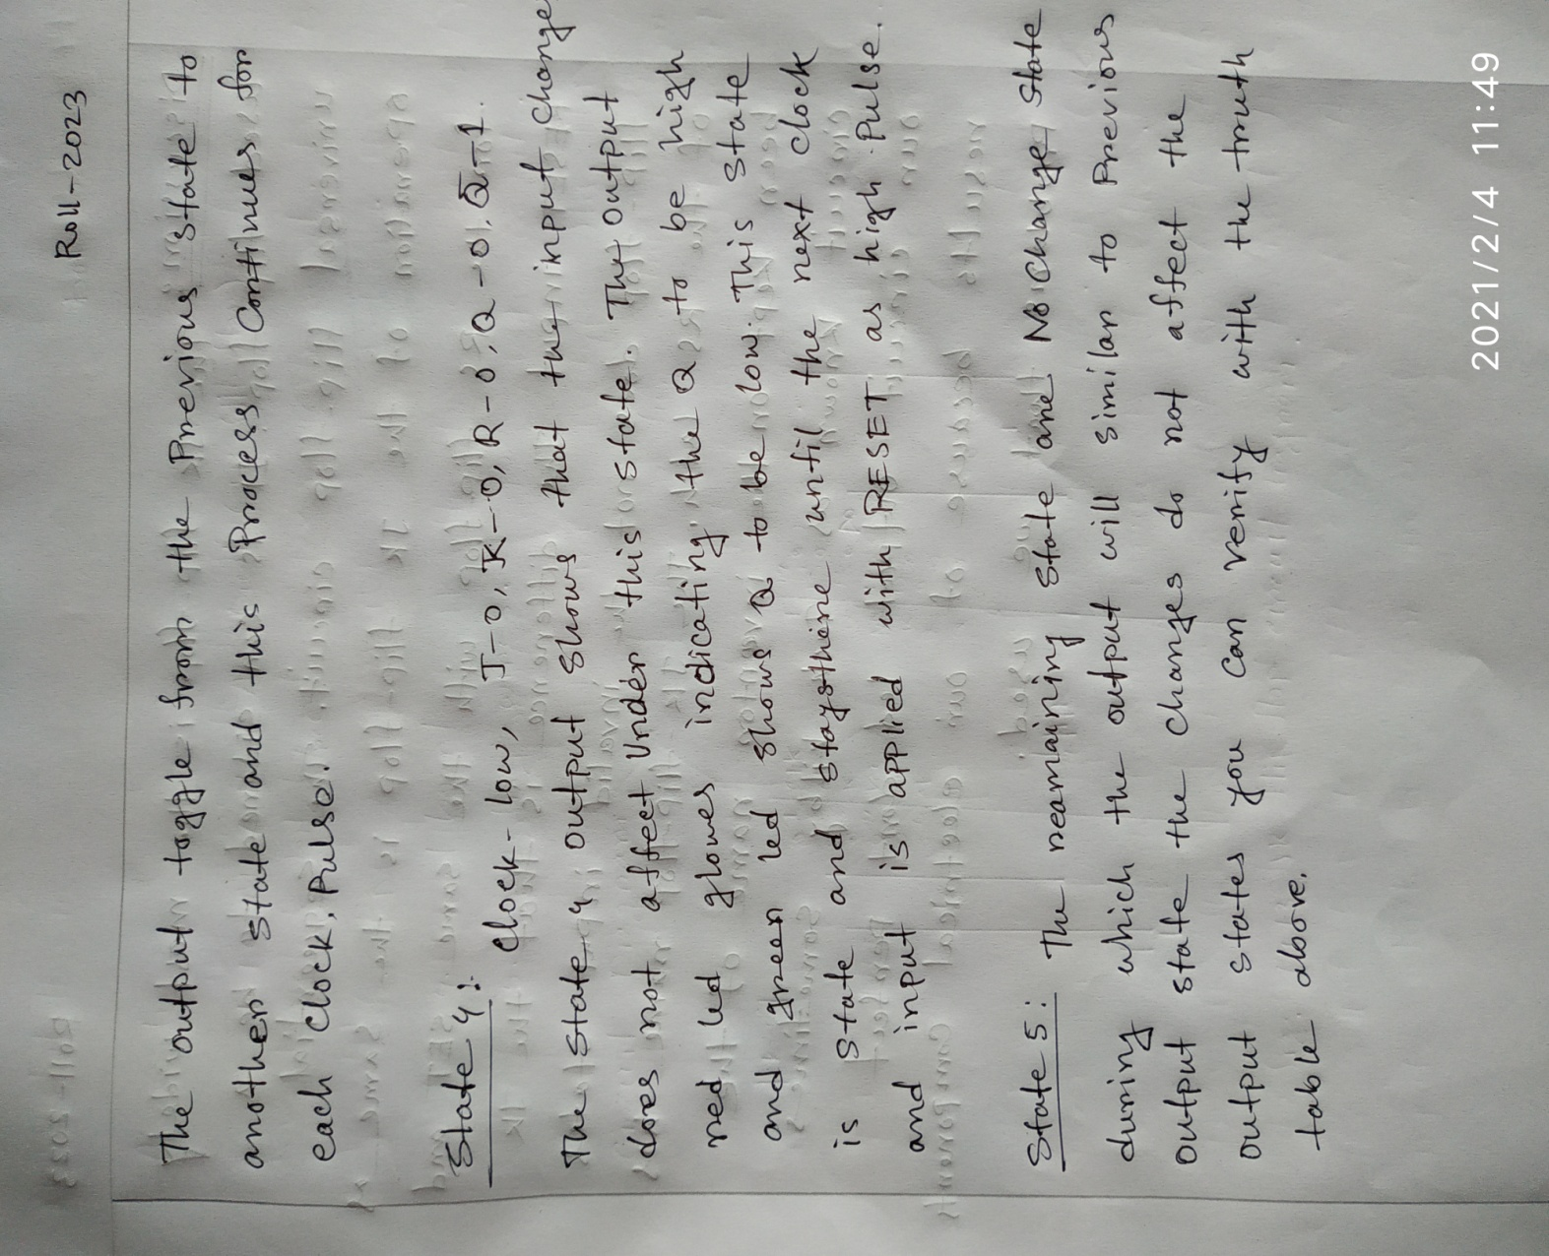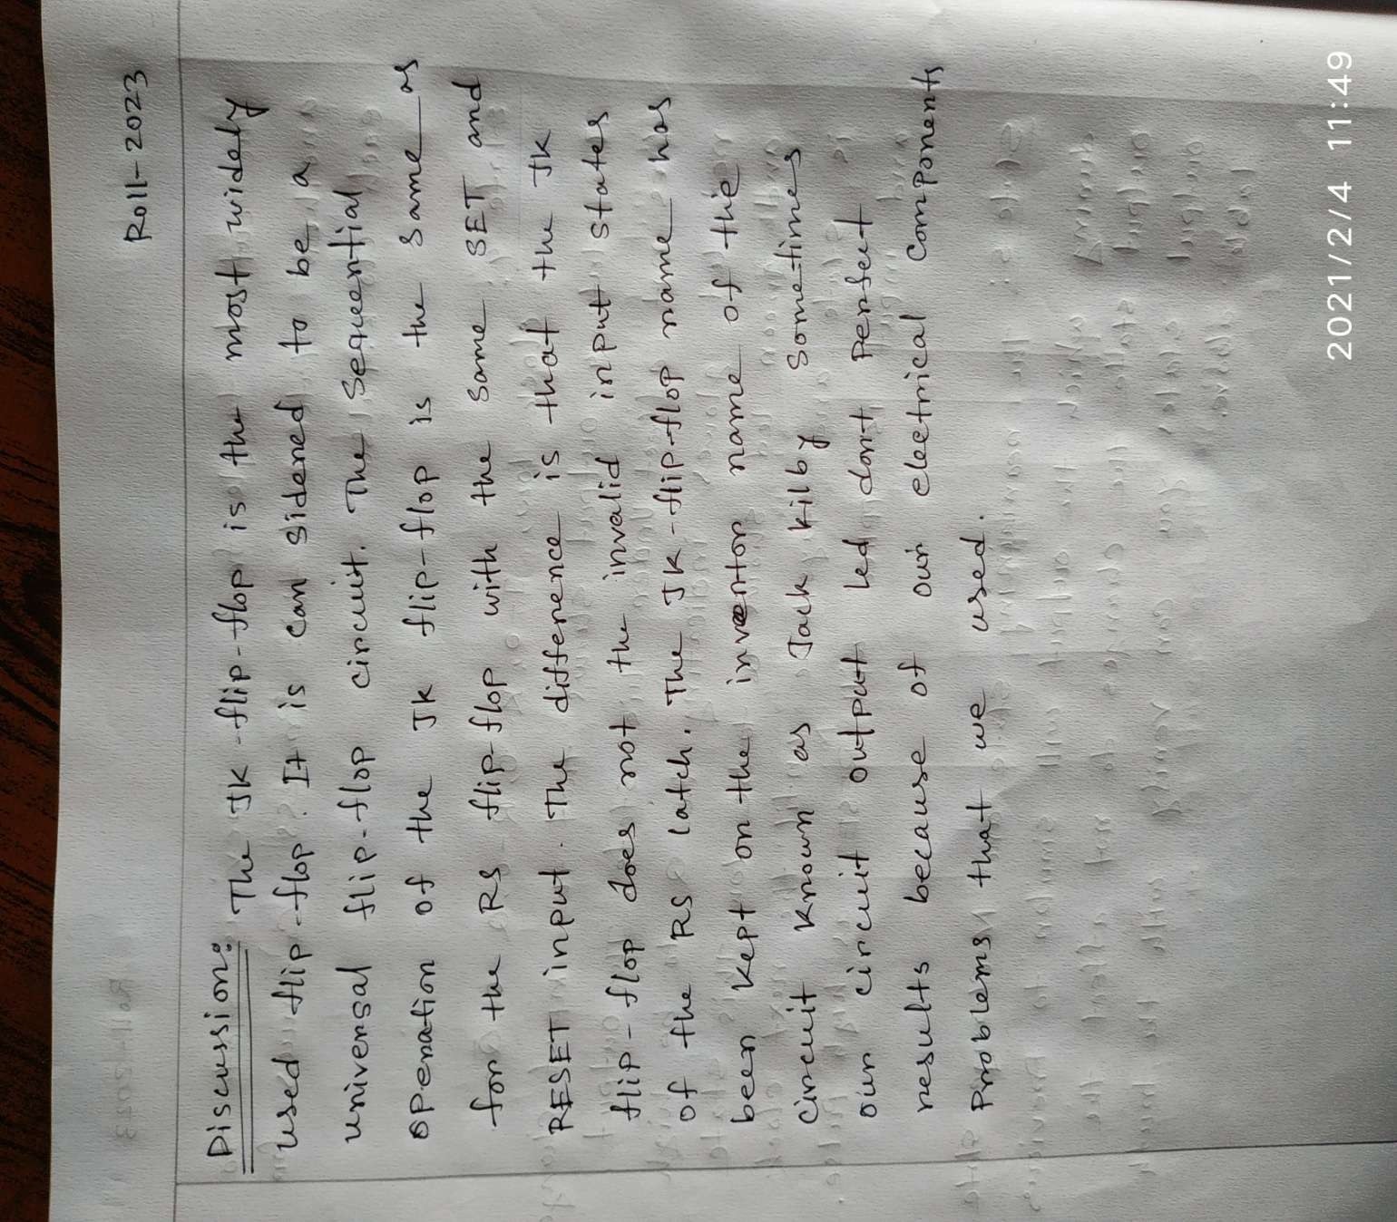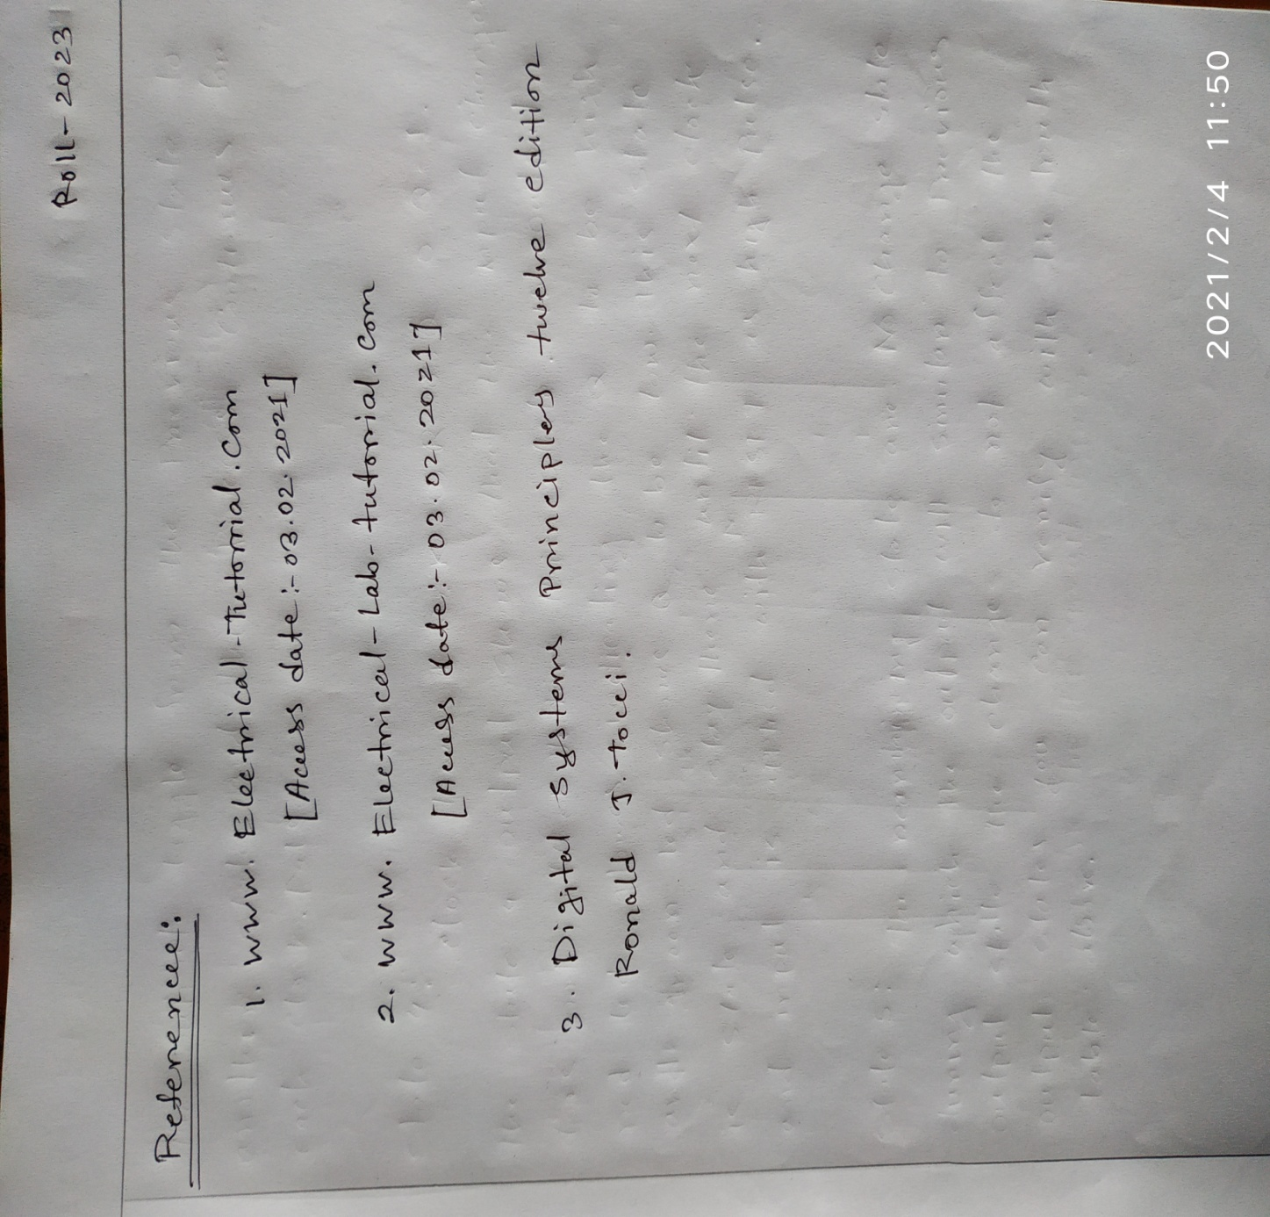

**THE END**